How to Manage a Status Page Without Losing Customer Trust
Downtime happens. Losing customer trust doesn’t.
For SaaS companies, e-commerce brands, and digital services that rely on uptime, your status page is your most critical communication channel when things go wrong. When managed well, it reassures customers, reduces support tickets, and strengthens trust, even during outages.
In this step-by-step guide, you’ll learn how to set up, manage, and optimize a professional status page using proven best practices, and how Instatus makes the process fast, clear, and reliable.

Why A Status Page is a Must for You
A status page isn’t optional anymore. It’s a business requirement.
Be transparent, build confidence. Customers don’t demand perfection; they want honesty. A live status page shows what’s working, what isn’t, and what you’re doing about it.
Communicate well when it matters most. Timely, thoughtful updates reassure users that you’re in control. Even bad news feels better when communicated clearly.
Reduce pressure on your support team. Instead of flooding your inbox with “Is your service down?” users check your status page first. That means less strain on your support team during high-pressure moments.
Own your presence in search. Well-optimized status pages can rank for searches like:
“Is [Your Brand] down?” “[Your Service] status”
This ensures users find accurate, official updates, not speculation on social media.

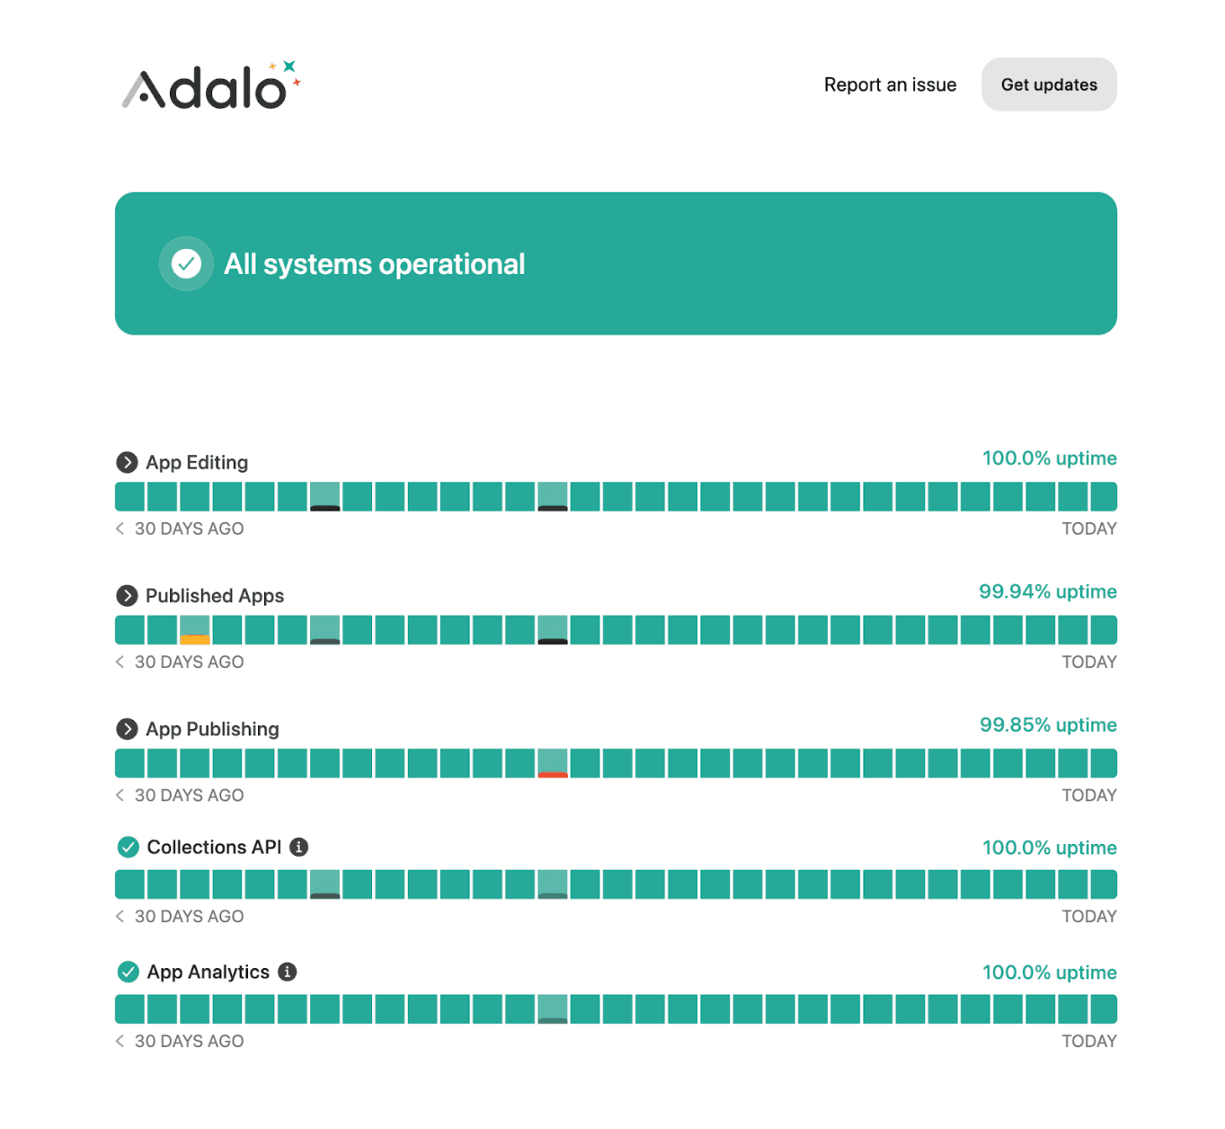
An Instatus public status page showing component uptime and recent notices.

Step 1: Set Up Your Status Page
You can build a status page yourself, or you can launch one that’s fast, reliable, and built for growth.
Most high-performing teams choose dedicated platforms like Instatus to publish professional, fully branded status pages in minutes, without writing a single line of code.

Choose the Right Tool
Look for:
- Quick setup
- Custom branding
- Subscriber notifications
- Monitoring and integrations
- Advanced security
With Instatus, you can:
- Go live in under 30 seconds
- Add your logo, brand colors, and custom domain
- Control visibility with public or private pages, password protection, IP allowlisting, and SSO
- Send updates via email, SMS, Slack, Discord, RSS, or webhooks.
Make It Easy to Understand
Answer three questions at a glance: “Is everything working?” “What’s affected?” “What’s being done?”
Instatus organizes services into components like Website, API, Payments, and Mobile App, making it simple for users to see what’s impacted, without digging through technical details.

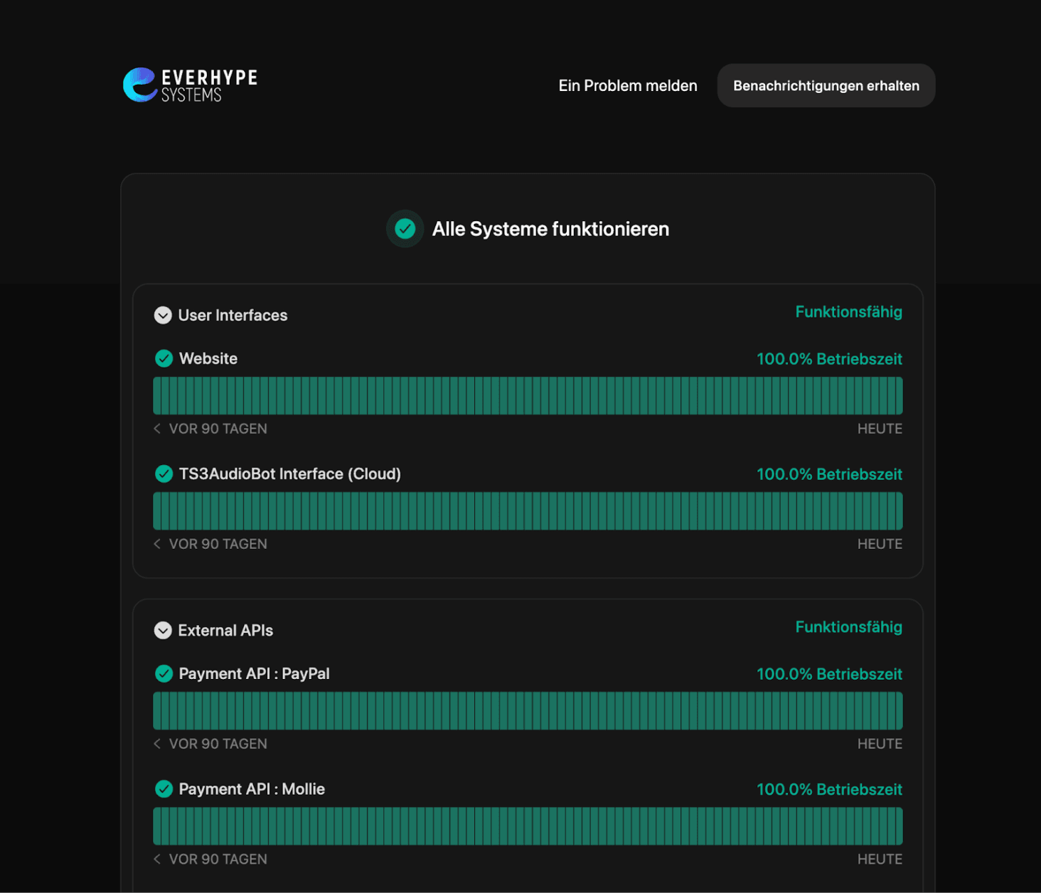
A live status page showing a fully customized, branded layout built with Instatus.

Monitor What Customers Actually Feel
Track what directly impacts user experience: uptime, performance, APIs, integrations.
With built-in integrations and API access, Instatus updates your page automatically, avoiding the risk of self-hosted pages going down during outages.
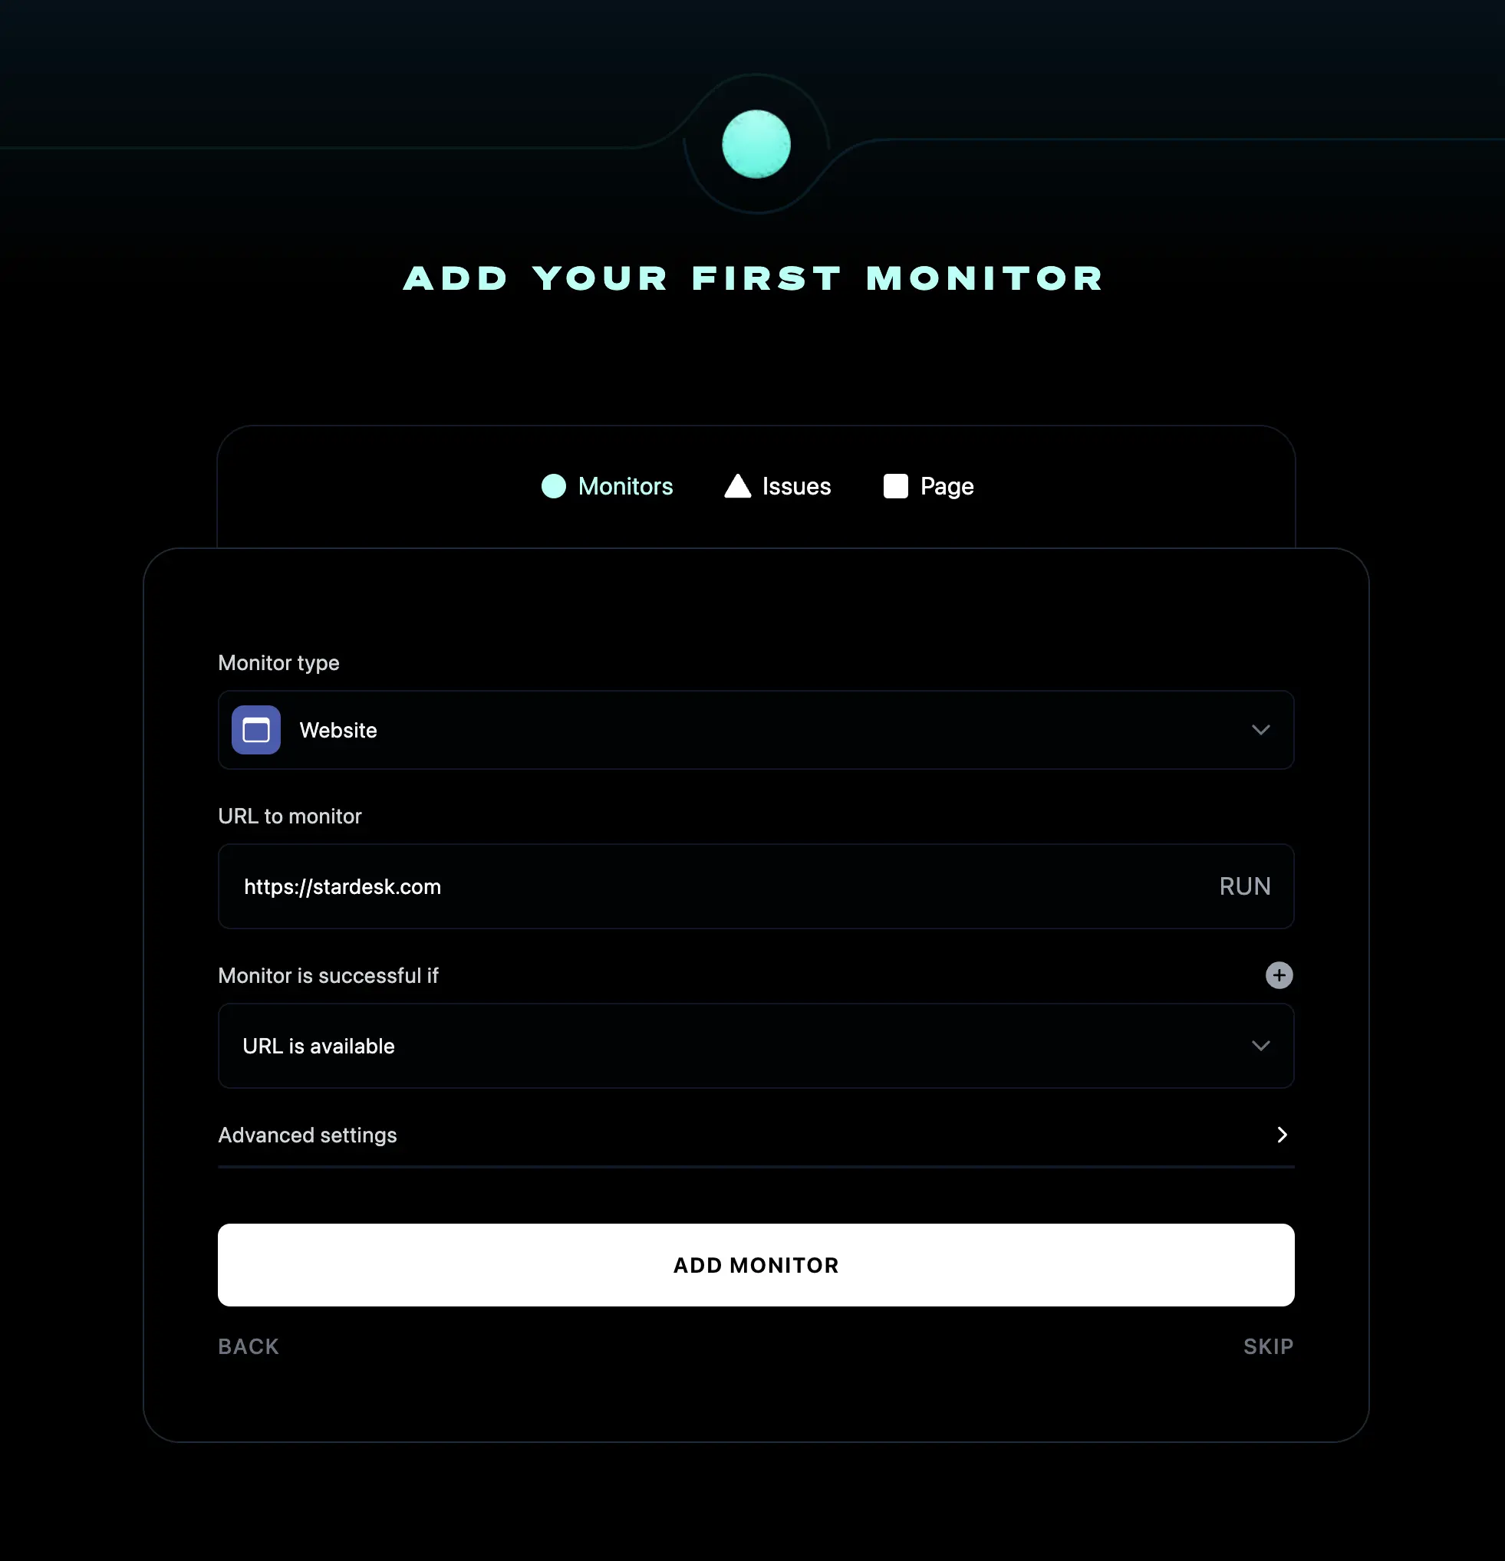

Instatus dashboard showing how to add the first monitor for uptime and performance tracking.

Enable Subscriptions & Alerts
Don’t make users refresh. Let updates come to them via email, SMS, Slack, Discord, RSS, or webhooks.

Step 2: Communicate Incidents Clearly

When something breaks, how you communicate matters more than how quickly you fix it. Speed and clarity beat perfection, every time.

Acknowledge Immediately
The moment you detect an issue, say something. Even a short update builds confidence:
“We’re investigating an issue affecting our API. Updates coming shortly.”
This tells customers you’re aware, engaged, and already working on it.

Keep the Updates Coming
Even if there’s no breakthrough yet, share progress. For major incidents, aim for updates every 30–60 minutes.
With Instatus, you can publish real-time updates to your status page while subscribers receive instant notifications. No extra effort required.

Skip Jargon, Keep It Real
If a fix is taking longer, explain why in plain language.
Instead of:
“We are experiencing intermittent degradation due to upstream dependency failures…”
Say:
“Our hosting provider is having issues, which is affecting our service. We’re working with them to resolve this as quickly as possible.”

Provide Options
If only part of your service is affected, tell users what still works:
“Desktop access is currently unavailable, but our mobile app is operating normally.”
Small details like this reduce frustration and keep customers moving.

Offer Realistic ETAs
Be honest about resolution times, updating users if timelines change. Transparency now prevents disappointment later.
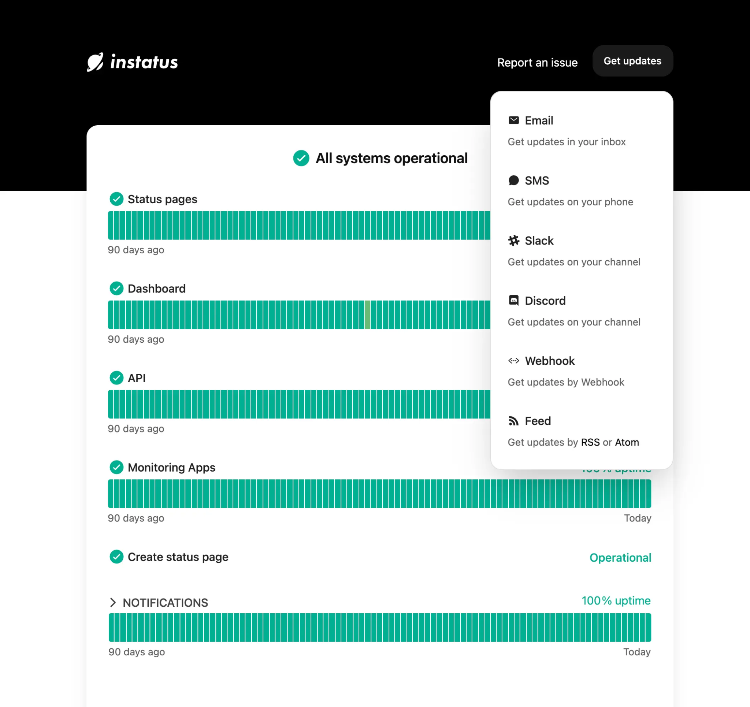
Instatus status page showing uptime history and subscriber notification options.

Step 3: Post-Incident Follow-Up (Where Trust Is Won)
Once systems are back online, communication shouldn’t stop. What you do after the incident is what customers remember.

Publish a Clear Incident Report
Transparency doesn’t end with resolution. Share what happened, how it was fixed, and what you’re doing to prevent it from happening again.
Explain:
- What happened
- How it was resolved
- The changes you’re making next
Example:
“On September 25th, we experienced a 45-minute outage caused by a database configuration error. The issue has been fixed, and we’ve added additional monitoring to prevent a recurrence.”
This level of clarity aligns with best practices around postmortem and RCA reports, and are shown to strengthen customer trust and reduce uncertainty.

Notify Subscribers of Resolution
Close the loop via the same channels: email, SMS, Slack, webhooks. Let customers know service has been fully restored.
Conduct an Internal Post-Mortem
Every incident is a chance to improve. Review internally:
- How quickly did we detect the issue?
- How clear and timely was our communication?
- What can we automate or improve next time?
Instatus makes this easier by keeping a complete history of incidents, updates, and timelines in one place, so your team can learn and respond faster next time.
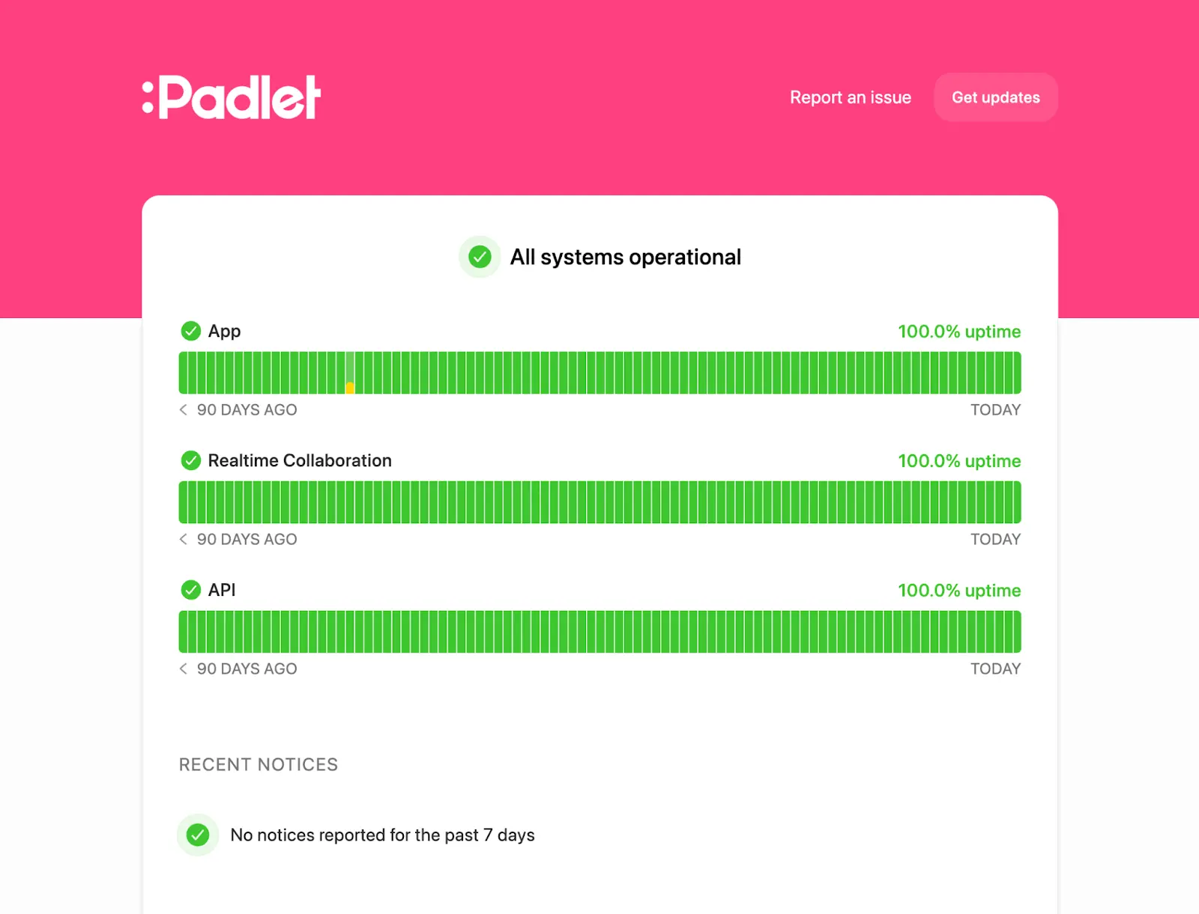
Padlet status page on Instatus displaying past incidents, uptime history, and resolved outages.

Step 4: Manage Scheduled Maintenance Like a Pro
Maintenance is unavoidable, but confusion isn’t. How you communicate planned downtime matters just as much as how you fix things.

Announce Early
Give at least 48 hours’ notice.
Example:
“Scheduled maintenance on September 27th from 1:00–4:00 AM UTC. The API will be unavailable during this time.”
With Instatus, you can publish upcoming maintenance windows and automatically notify subscribers, so no one is caught off guard.

Choose Off-Peak Hours
Schedule maintenance when usage is lowest across regions to minimize disruption.

Track Status
Planned downtime doesn’t mean “set it and forget it.” Monitor your systems and update users if issues arise.
Confirm Completion
When everything is done, say so.
“Maintenance completed successfully. All systems are operational.”
That final update restores confidence and closes the loop.
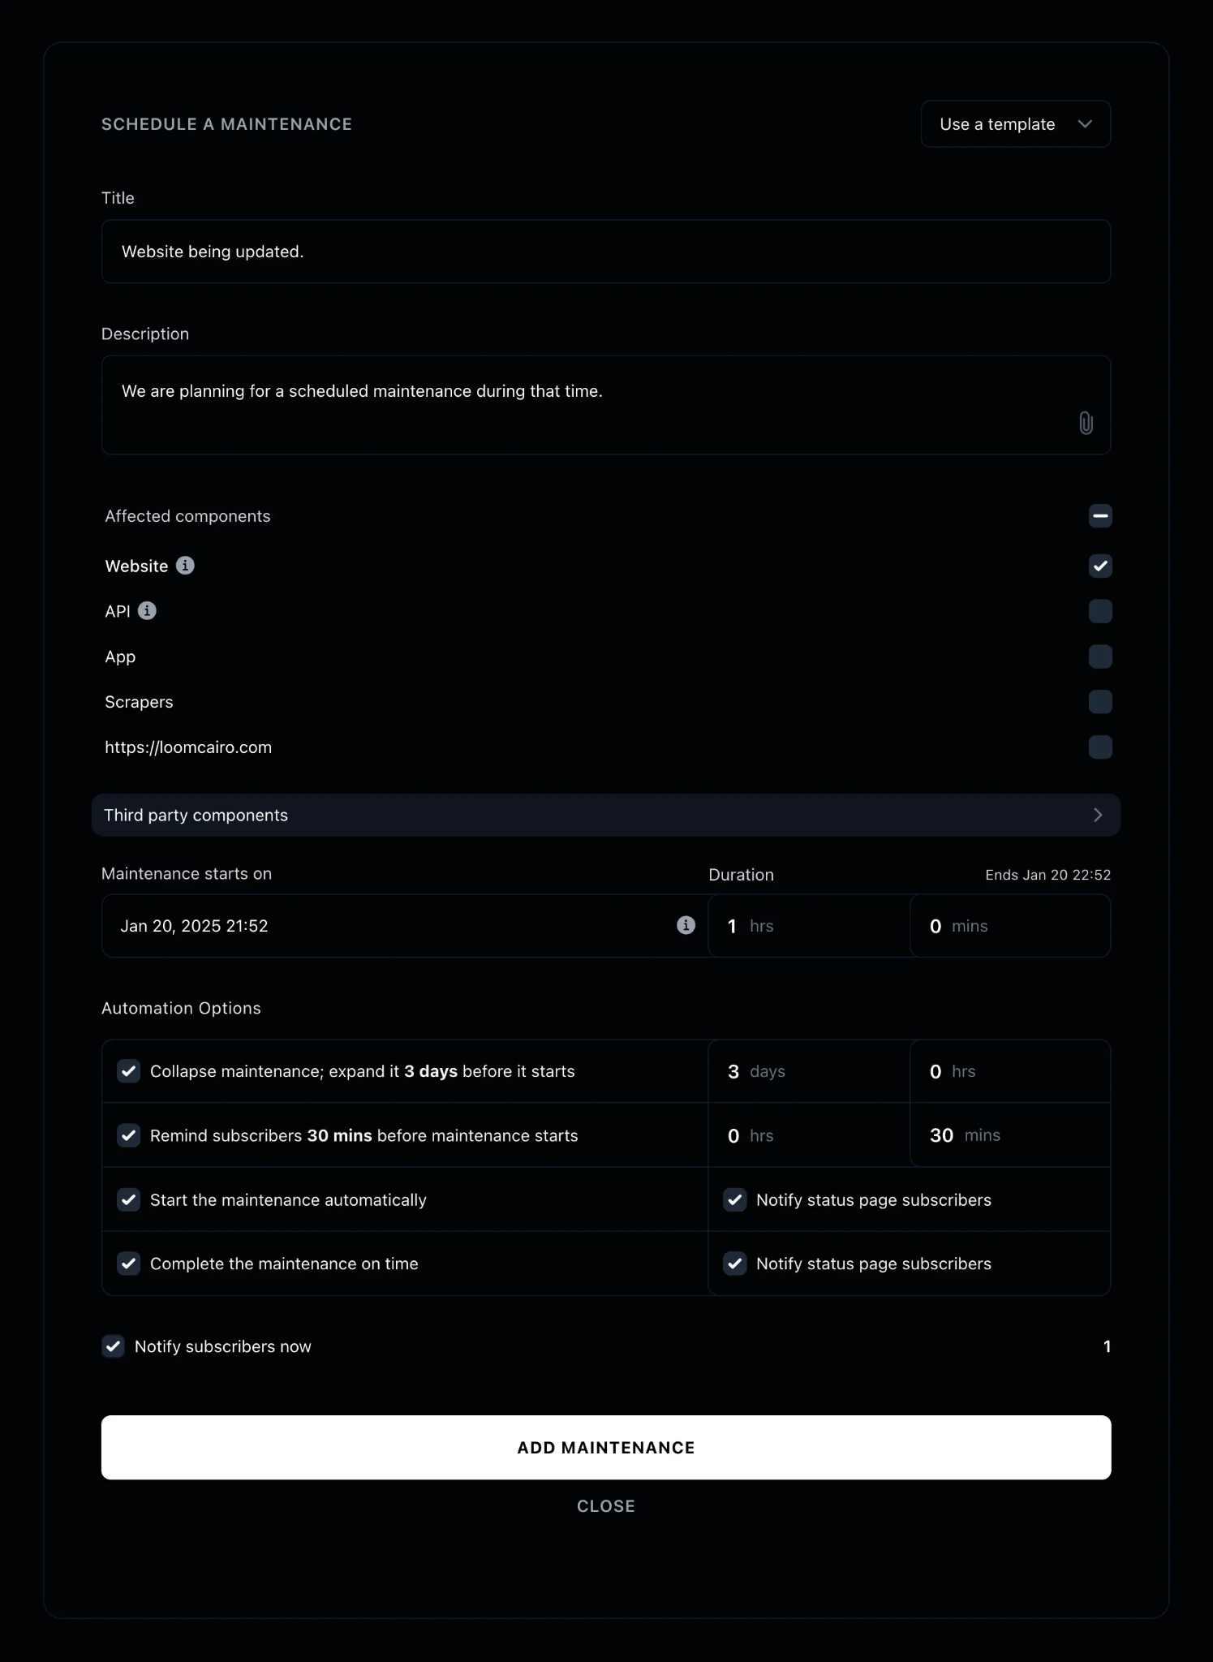
Instatus dashboard screen showing how to schedule planned maintenance and configure notifications.

Step 5: Optimize Your Status Page for SEO & Growth
Your status page isn’t just for existing users. It's also a powerful discovery and trust asset. When people search for answers during an outage, your page should be the first thing they find.

SEO Best Practices
Optimize for high-intent searches such as:
- “[Your Brand] status”
- “Is [Your Service] down?”
- “Service outage updates”
Use SEO fundamentals that search engines (and users) love:
- Clean, readable URLs
- Proper heading structure (H1, H2, H3)
- Structured data (schema markup)
Instatus pages are built to be fast, lightweight, and search-optimized by default.
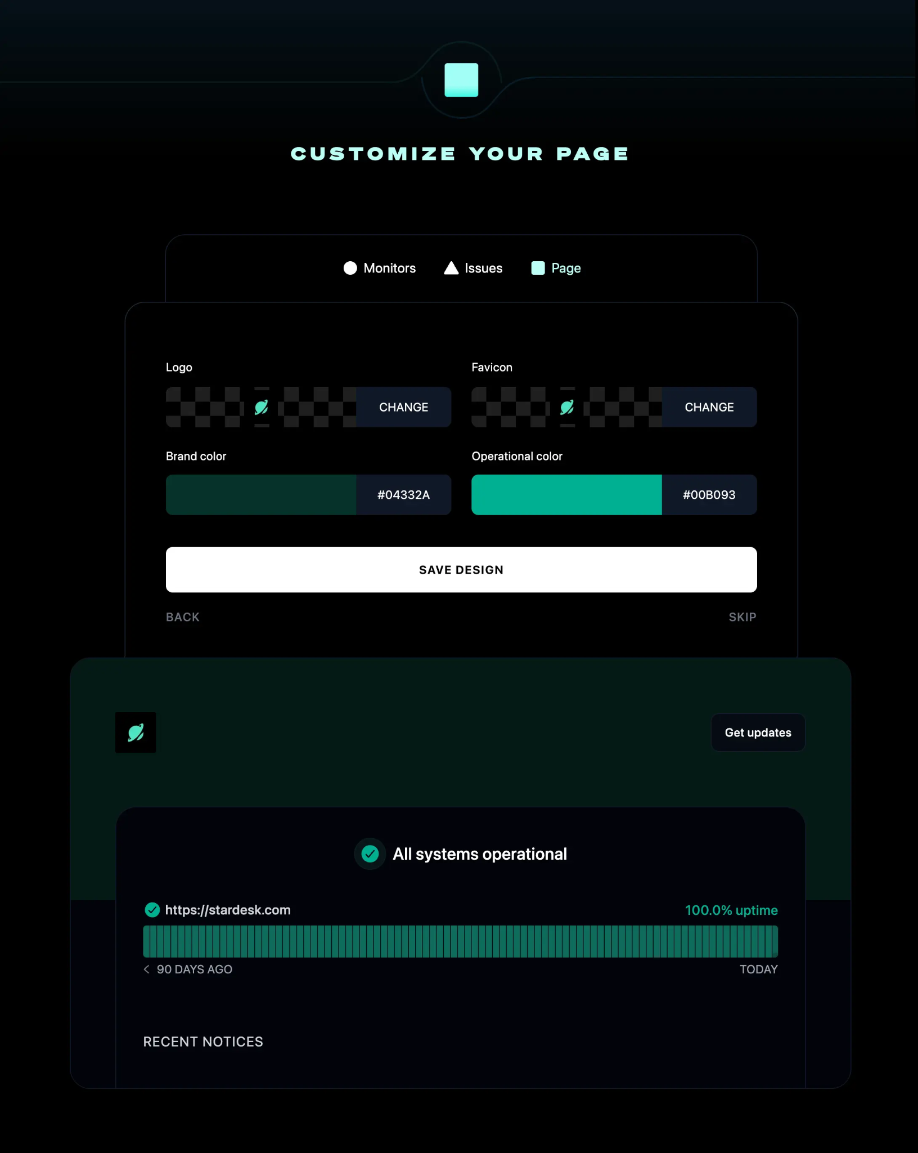

Instatus customization interface showing service components and SEO-optimized layout.

Track Feedback & Continuously Improve
Your status page should evolve with your product. Monitor how users interact with it:
- Are updates clear and easy to understand?
- Are subscribers engaging with notifications?
- Are support tickets decreasing during incidents?
Use these insights to refine your messaging, layout, and communication strategy, so every outage becomes an opportunity to improve the experience.

Why Teams Choose Instatus
Beyond features, real users consistently praise Instatus for its simplicity, design, and value:
⭐ 4.8/5 rating on GetApp & Capterra
⭐ 4.9 out of 5 stars overall on G2
⭐ Trusted by Stytch, Vercel, Wistia, Sketch, Harvard, and more
⭐ Blazing fast pages with real-time notifications
⭐ Beautiful, simple, affordable
What users say:
“Working with Instatus has been amazing. If I ever have a question or problem, it’s resolved super quickly. It really felt like a partnership — Chris Howard, Stytch
“You’ve built a great product. I recommend it for anyone who wants a no-frills, blazing fast status page.” — Guillermo Rauch, CEO - Vercel
“The best platform for incident reports. Period.” — Jay Desai, Capterra

Finally,

A well-managed status page is one of the most powerful tools in your customer communication stack. Communicate clearly, follow up thoughtfully, and keep it search-friendly. With Instatus, every incident becomes a chance to show your customers they can rely on you.

